www.qaprogrammer.com

Performance Test report

# **Test Details**

* **Test Date:** 11/10/2019
* **Load:** 3000 Users
* **Duration:** 30 Mins
* **Environment:** qa.purchasingpower.travel

# **Observations & Recommendations**

* All Failures are due to 500 & 503 Errors
* Application started throwing errors from ~100 Users.
* **Random View Of Hotels –** Has less number of transactions compared to **Search** due to most of the Searches did not returned any results and thrown errors.
* **Random View Of Hotels** also failed with a higher percentage due to Service Unavailable & TimeOut
* Observed Errors gradually started from 1500 Concurrent Users, spiked to high at 3000 Users, continued till end of the test.

# **Response Time Summary**

|  |  |  |  |  |  |  |  |  |  |
| --- | --- | --- | --- | --- | --- | --- | --- | --- | --- |
|  |  | **Response Time in Seconds** | | | | | | |  |
| **Transaction/Page** | **# Samples** | **Average** | **Median** | **90% Line** | **95% Line** | **99% Line** | **Min** | **Max** | **Error %** |
| 01-OpenURL | 24956 | 73.262 | 68.523 | 127.816 | 143.674 | 166.236 | 0 | 205.826 | 9.86% |
| 02-Enter NewYork City | 20645 | 42.201 | 42.368 | 76.035 | 89.223 | 109.305 | 0.91 | 114.363 | 5.70% |
| 03-Search | 19198 | 91.74 | 95.696 | 140.625 | 151.311 | 171.399 | 0.013 | 212.54 | 45.60% |
| 04-RandomView_Hotel | 2554 | 107.014 | 109.34 | 164.59 | 179.659 | 203.133 | 0 | 235.756 | 42.52% |

# Concurrent Users

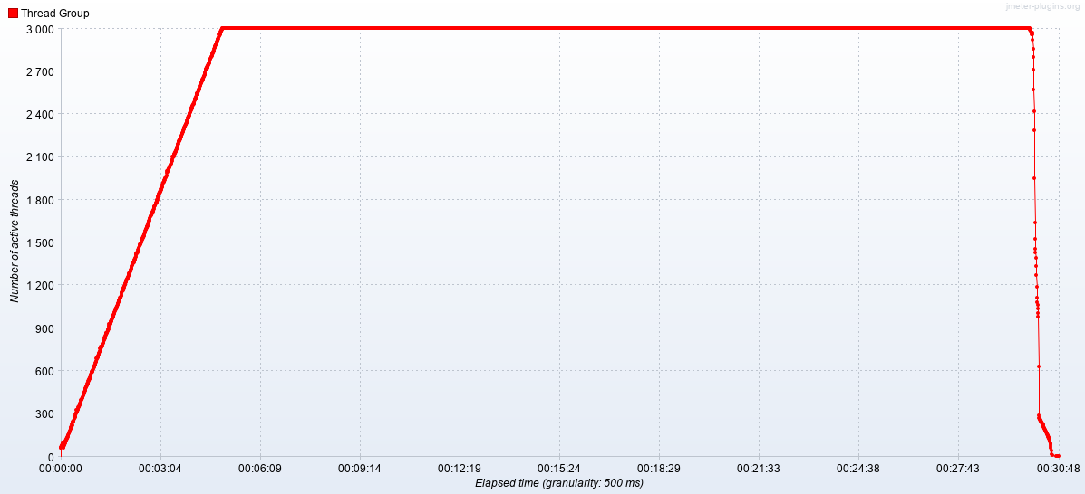

# Response time over time

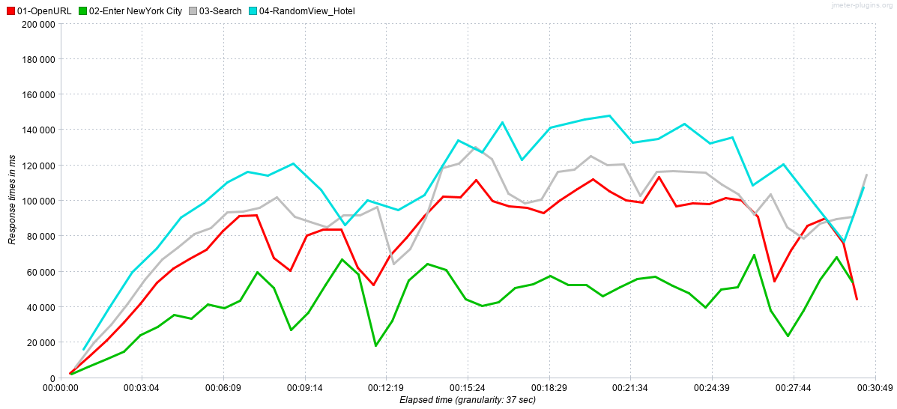

# Random Snap shots of Error

